**NODE RED**

Node-RED is a programming tool for wiring together hardware devices, APIs and online services in new and interesting ways.

It provides a browser-based editor that makes it easy to wire together flows using the wide range of nodes in the palette that can be deployed to its runtime in a single-click.

Node-RED provides a browser-based flow editor that makes it easy to wire together flows using the wide range of nodes in the palette. Flows can be then deployed to the runtime in a single-click.JavaScript functions can be created within the editor using a rich text editor.A built-in library allows you to save useful functions, templates or flows for re-use.

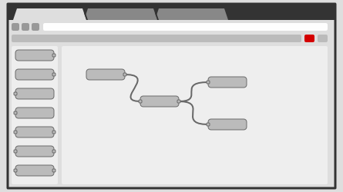

The light-weight runtime is built on Node.js, taking full advantage of its event-driven, non-blocking model. This makes it ideal to run at the edge of the network on low-cost hardware such as the Raspberry Pi as well as in the cloud.With over 225,000 modules in Node's package repository, it is easy to extend the range of palette nodes to add new capabilities.

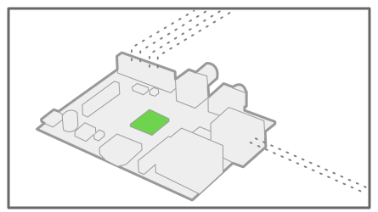

The flows created in Node-RED are stored using JSON which can be easily imported and exported for sharing with others.An online flow library allows you to share your best flows with the world.

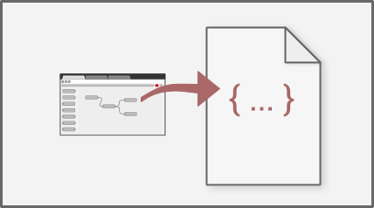

# Running on IBM Cloud

Node-RED is available on the IBM Cloud platform as one of the [Starter Kits applications](https://nodered.org/docs/getting-started/ibmcloud#starter-kit-application) in the catalog.

We also provide a ‘[Deploy To IBM Cloud](https://nodered.org/docs/getting-started/ibmcloud#deploy-to-ibm-cloud)’ enabled repository.

Starter Kit application

1. Log in or sign-up for an account at [cloud.ibm.com](https://cloud.ibm.com/)
2. Navigate to the catalog and [search for ‘Node-RED’](https://cloud.ibm.com/catalog?search=node-red). This will present you with the **Node-RED Starter**. This gives you a Node-RED instance running as a Cloud Foundry application. It also provides a Cloudant database instance and a collection of nodes that make it easy to access various IBM Cloud services.
3. Click the starter application you want to use, give it a name and click create.

A couple of minutes later, you’ll be able to access your instance of Node-RED at https://<yourAppName>.mybluemix.net

#### **Customising your Node-RED application**

#### To start customising your instance of Node-RED, you can either download the application locally or you can enable the Continuous Delivery integration option via your application’s IBM Cloud dashboard page. That will create a git repository on either GitHub or IBM DevOps services, from where you can customize your Node-RED, save the changes and automatically update the application in IBM Cloud.

##### **Securing the editor**

When you first ran the Node-RED instance you were presented with some options to secure the editor. To change those options, you can set some environment variables from either the IBM Cloud console or the cf command-line

1. In the IBM Cloud dashboard, select the ‘Environment Variables’ page for your application
2. Add the required user-defined variables:
   * NODE_RED_USERNAME - the username to secure the editor with
   * NODE_RED_PASSWORD - the password to secure the editor with
   * NODE_RED_GUEST_ACCESS - set to true to allow anonymous users to have read-only access to the editor
3. Click Save.

##### **Adding nodes**

##### You can add nodes from within the editor. Select the manage palette option from the dropdown menu within the editor.

Alternatively, you can edit the application’s package.json file and add the required node modules in the dependencies section. The format is: "node-red-node-package-name":"x.x.x" Where x.x.x is the desired version number.

#### **Customising your Node-RED repository**

The repository is there to be cloned, modified and re-used to allow anyone to create their own Node-RED based application that can be quickly deployed to IBM Cloud.

The default flows are stored in the defaults directory in the file called flow.json.

The web content you get when you go to the application’s URL is stored under the public directory.

Additional nodes can be added to the package.json file and all other Node-RED configuration settings can be set in bluemix-settings.js.

If you do clone the repository, make sure you update the README.md file to point the Deploy to IBM Cloud button at your repository.

If you want to change the name of the Cloudant instance that gets created, the memory allocated to the application or other deploy-time options, have a look in manifest.yml.